Experiment: Mixed Signal Ground Technique

Summary: Goal of this experiment is to teach users about signal degradation issues that occur as a result of improper ground techniques in mixed signal applications. The user will be able to see the effect that different return paths have on an analog signal.

Equipment:

* Signal Generator
* Oscilloscope
* Power Supply (Optional)

Setup:

1. Connect USB Mini cable to USB Mini Power port. If using power supply connect power supply to JP13. The top pin in power and the bottom is GND.
2. Connect the Signal Generator to the INPUT jumper. The positive is on the right and the GND is on the left.
3. Connect resistive jumpers to IN1 and RF1.
4. Connect Oscilloscope probe to OUT1 the left is positive and the right is GND.
5. Connect JP6 to route the return path directly to the source.
6. Disconnect JP6 and Connect JP5 to route the return path through the Analog circuit.
7. Switch between JP5 and JP6 notice the effects.

Work Around Setup (using current board):

1. Connect power supply to JP13. The top pin in power and the bottom is GND.
2. Connect the Signal Generator to the INPUT jumper. The positive is on the right and the GND is on the left.
3. Connect Separate Signal Generator to white cable soldered to clk input of inverter. Set Clk amplitude 5V with 2.5 V offset. Set frequency to 5 – 10 MHz. Connect GND lead to common ground at power supply.
4. Connect resistive jumpers to IN1 and RF1.
5. Connect Oscilloscope probe to OUT1 the left is positive and the right is GND.
6. Connect JP6 to route the return path directly to the source.
7. Disconnect JP6 and Connect JP5 to route the return path through the Analog circuit.
8. Switch between JP5 and JP6 notice the effects.

Changes Completed:

* Fix error with Op Amp setup. Previous revision had feedback connected to the source instead of after the input resistor. Caused the source to bypass the op amp all together.
* Increased isolation between the analog and digital ground planes.
* Made inverters enabled by user. Allows for user to see the effects of one, two, or three inverters turned on.
* Increased the size of the board.

Recommend Direction for Future:

* Create different topologies for analog circuits.
* Move common ground to different areas of the circuit.

Current Layout:

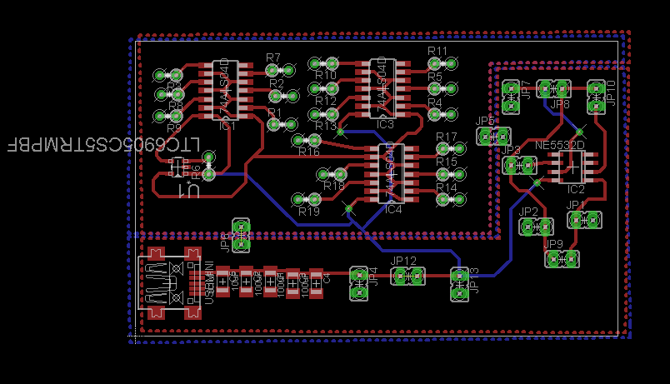

Revised Layout:

